DIS-AM,C-Taino-Pendant-Maquetaurie Guayaba-Porphyritic Rhyolite-1000 CE

Case no. 18

Eyes closed, no lips hence bared teeth-no navel which indicates it has no beginning --this is the deity of the Land of the Dead, Maquetaurie Guayaba

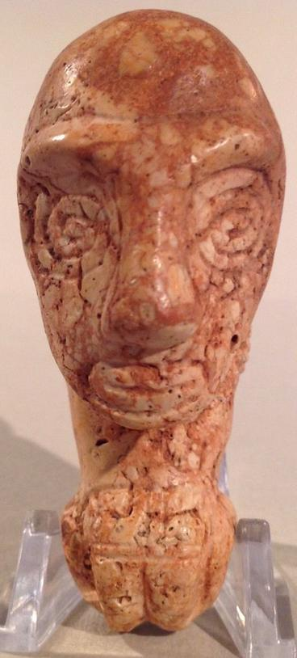 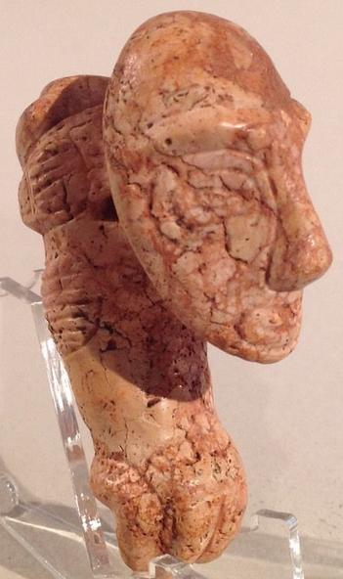

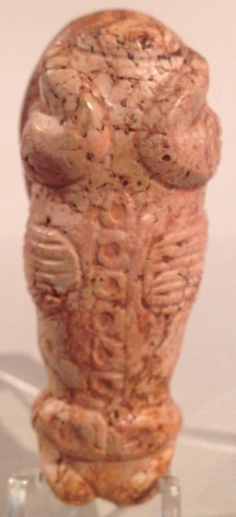 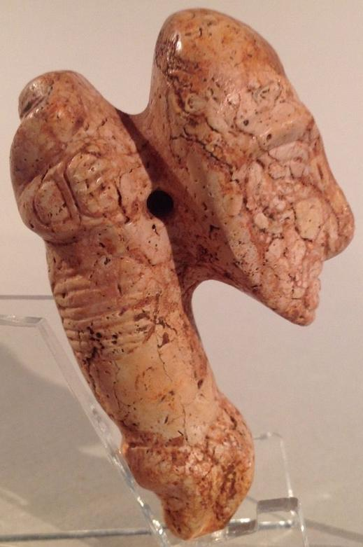

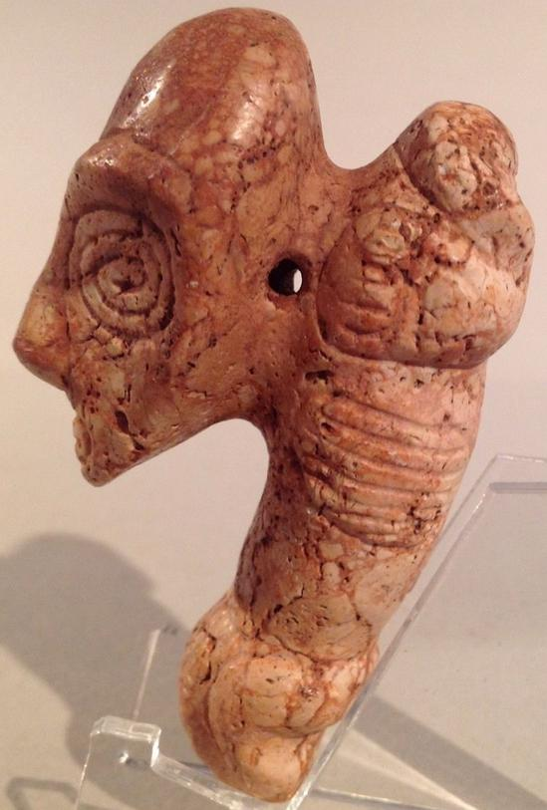

Sold by [flapast](http://myworld.ebay.com/flapast) ( [13289](http://feedback.ebay.com/ws/eBayISAPI.dll?ViewFeedback&userid=flapast) )

### Delivery package 1 of 1

Estimated delivery Wednesday, Dec 23, 2015 - Monday, Dec 28, 2015

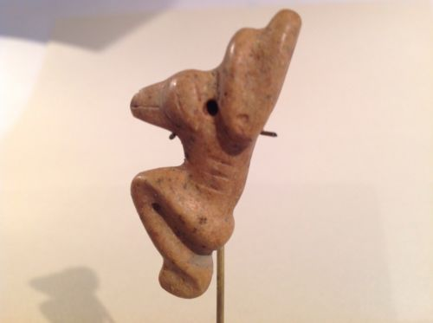

#### [Taino Stone Pendant, Bird-Human Transformation, Pre Columbian](http://www.ebay.com/itm/262187077871)

|  |  |
| --- | --- |
| Item price | $160.50 |
| Quantity | 1 |
| Item number | 262187077871 |
| Shipping service | USPS Priority Mail |

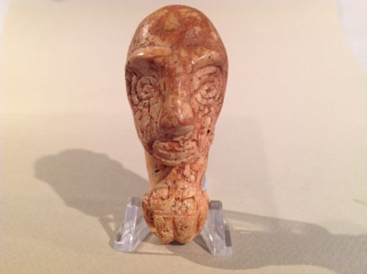

#### [Taino Pendant Anthropic Figure, Pre Columbian](http://www.ebay.com/itm/262187093894)

|  |  |
| --- | --- |
| Item price | $305.00 |
| Quantity | 1 |
| Item number | 262187093894 |
| Shipping service | Economy Shipping |